# U-Shaped Microstrip Patch Antenna with Partial Ground Plane for Mobile Satellite Services

# (MSS)

**Abstract**—In this paper, we present a new dual band u-shaped antenna. The proposed antenna consists of a microstrip patch with a U-shaped slot that is fed by a broadband electromagnetic coupling probe, known as L-probe. Radiation characteristics of the antenna and different methods for control of the resonant frequencies are investigated.

**1.INTRODUCTION:**

Since the time when wireless communication started seeing big advancements and started to gain popularity in the day to-day applications, more and more researchers have made use of the recent technologies to develop high gain, high efficiency, and small sized antennas with omnidirectional radiation patterns. Microstrip patch Antennas gain popularity in the 1970s primarily for space bound applications. Today they are used for government as well as commercial applications. It consists of a substrate (usually FR-4) of a particular length, a thin ground plane (usually copper) on one side and a thin patch attached to a microstrip line (copper) on the other side. To realize a broadband characteristic in feeding a microstrip antenna, an L-probe can be used. This feeding structure is also known as broadband electromagnetic coupling probe [6].

In this paper, dual band characteristics are achieved by embedding a U-shaped slot in a rectangular patch. Also, an L-probe is used to realize matching between the feed system and radiating system in a wide frequency range. Radiation performance of the designed antenna is simulated using the HFSS software and the simulated results are validated by experimental results. This paper proposes a microstrip patch antenna, with a U-shaped patch with the diagonally cut partial ground plane. The optimum size of the proposed monopole antenna is 20*20*1.5 mm3. The compact monopole patch antenna shows stable radiation pattern. The gain and the radiation efficiency of the first band (from 1.9 to 2.2 GHz) is 3.2 dB and 22%, for second band (from 3.9 to 4.8 GHz) gain and the radiation efficiency are 1.2 dB and is 75% is observed. In the next section the geometry of the antenna is elaborated.

**LITERATURE SURVEY:**

1. M. Karthick, “Design of 2.4GHz Patch Antennae for WLAN Applications,” IEEE Seventh National Conference on Computing, Communication and Information Systems (NCCCIS), 2015.
2. S. Baudha and D. k. Vishwakarma, “Bandwidth enhancement of a planar monopole microstrip patch antenna,” Int. J. Microw. Wireless Technol., vol. **12**, 2014, pp. 1–6.
3. Petosa, P. Strickland, J.S. Wight, “Microstrip antenna array for mobile satellite communications,” IEEE Antennas and Propagation Society International Symposium 1992 Digest. 1992, pp.503-506.
4. Jen-Yea Jan, Jia-Wei Su, “Bandwidth Enhancement of a Printed Wide-Slot Antenna With a Rotated Slot,” IEEE transactions on antennas and propagation, vol. **53**, no. 6, June 2005.

**EXISTING METHOD:**

**ANTENNA CONFIGURATION:**

The configuration of the proposed antenna is shown in Fig. 1(a). The substrate used for this design is RF-35 with relative permittivity of 3.5, loss tangent of 0.0018 and thickness of *h*1 = *h*2 = 1*.*524mm. Dimensions of the ground plane are also 100mm × 100mm. As shown in Fig. 1, the radiating element is a square patch

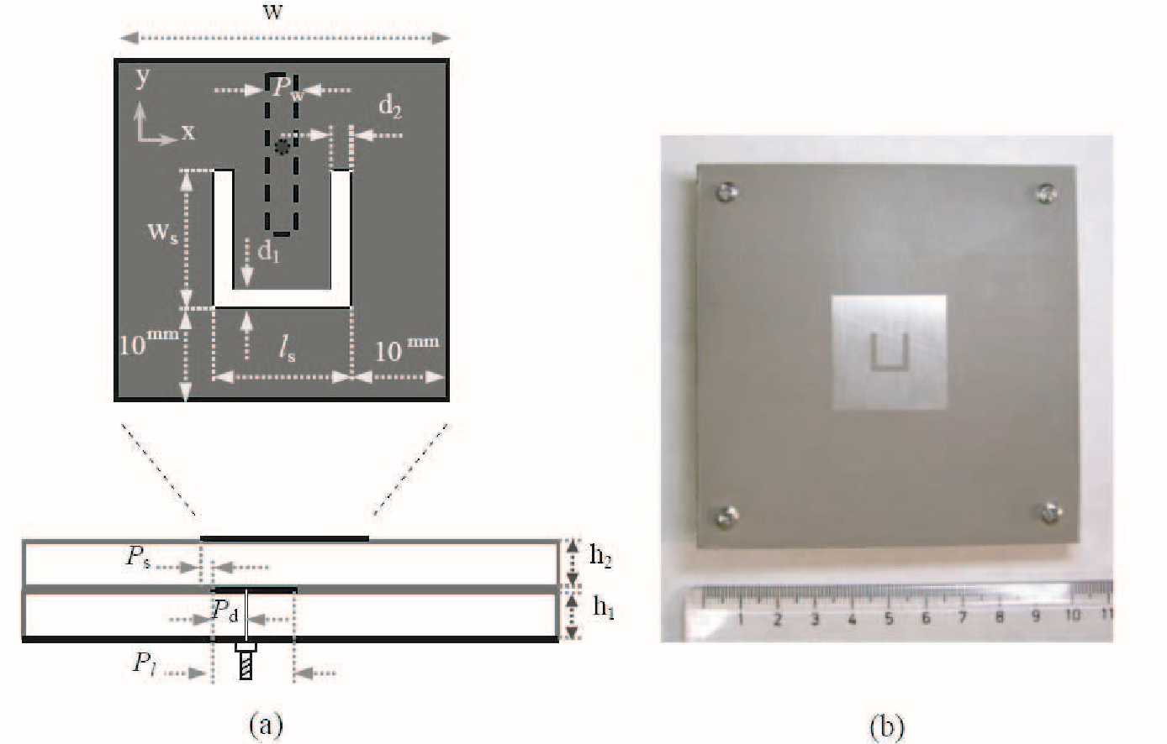

*y*

*z*

(

a

)

(

b

)

**Figure 1.** Configuration of the proposed antenna, (a) top view of the radiating patch and side view of the whole antenna structure, (b) photograph of the fabricated antenna.

with a U-shaped slot. The radiating patch is fed by a broadband electromagnetic coupling probe, known as L-probe. By using the slot, the dual band operation of the antenna can be achieved. In general, the first resonant frequency is associated with the size of the square patch and the second resonant frequency is associated with the Uslot parameters. The other parameters in Fig. 1 (*Pd*, *Pw*, *Pl*, *Ps*) are optimized to achieve good impedance matching at both resonant frequencies. For obtaining two resonant frequencies at 2.28GHz and 3.80GHz, optimum values of the structural parameters of the antenna are as follows.

*w* = 30mm*, ws* = 10mm*, ls* = 10mm*, d*1 = 1*.*5mm*, d*2 = 1*.*5mm *Pl* = 15mm*, Pw* = 2*.*5mm*, Ps* = 1*.*75mm*, Pd* = 7*.*05mm

The proposed antenna with optimum dimensions has been fabricated. Fig. 1(b) demonstrates the photograph of the fabricated antenna.

# RETURN LOSS:

Figure 2(a) illustrates both the simulated and experimental results of the antenna return loss. Here, return loss is defined as *R* = 20 × log10 |Γ|, where Γ is the reflection coefficient. As shown in this figure, experimental values of the first and second resonant frequencies are 2.31GHz and 3.78GHz, respectively. Current paths of the 1st and 2nd modes are shown in Fig. 2(b). Dash-dot lines show the average length of current paths for each mode.

In accordance with results shown in Fig. 2(b) the resonant frequencies can be calculated approximately as follows:

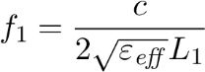 (1)

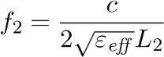 (2)

where *L*1 and *L*2 are the average lengths for current paths of the 1st and 2nd resonant modes and *c* is the free space velocity of light. The effective permittivity (*εeff* ) is also given by [7]:

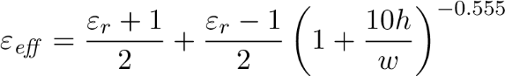 (3)

where *h* and *w* are height of the substrate and width of the patch, respectively. The above equation, which is given in [7], is valid for single layer substrates. However, while the effect of L-shaped feed system is negligible, this equation can be used for two-layered substrates

2.2

2.6

3

3.4

3.8

4.2

-40

-30

-20

-10

0

Return Loss (dB)

Simulated

Experimental

Frequency (GHz)

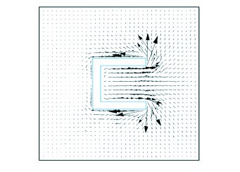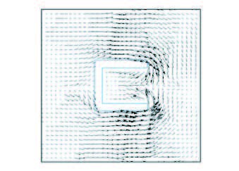

L

1

L

2

(

a

)

(

b

)

*f =*

2.28

GHz

*f*

= 3.80 GHz

**Figure 2.** (a) Return loss of the antenna, (b) current paths of the 1st and 2nd modes.

provided that the parameter *h* is substituted by the total height of *h*1 + *h*2.

The average lengths for current paths of the 1st and 2nd resonant modes can be obtained by using the following approximate relations:

*L*1 = *α*1*ls* + *α*2*ws* + *α*3*w.* (4)

*L*2 = *β*1*d*1 + *β*2*d*2 + *β*3*ls* + *β*4*ws.* (5)

Based on results of several simulations, optimum values of *αi* and *βi* in the above equations are obtained as follows.

*α*1 = 0*.*385*, α*2 = 0*.*445*, α*3 = 1*.*000

*β*1 = −1*.*097*, β*2 = 0*.*630*, β*3 = 0*.*876*, β*4 = 1*.*412

For the values of parameters given in Section 2, the average lengths of current paths for the 1st and 2nd resonant modes are obtained as *L*1 = 38*.*3mm and *L*2 = 22*.*2mm. Also, the effective permittivity is obtained as 3.097. Thus, Equations (1) and (2) give the resonant frequencies of 2.23GHz and 3.84GHz, respectively.

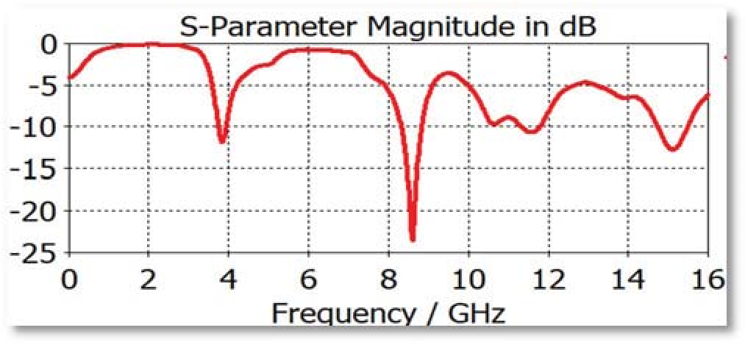

**PROBLEM STATEMENT:**

In the above existing method its taking a lot of power consumption. Return loss i.e. S-Parameter graph is not up to mark for given operating frequency. So, in the proposed method I will improve the S-Parameter magnitude graph and I will improve the antenna total gain and directivity and make it efficient at operating frequency 25GHz. The materials I will use in the proposed method are radiation box of rectangular size (called as AIR ) of solid type and a lumped impedance and rectangular planes, Rogers RT substrate of solid type and a ground. I will make it analyzed under the following conditions such as : frequency = 25 GHz, delta S =0.02, passes=20.

**PROPOSED METHOD:**

**ANTENNA CONFIGURATION:**

The top view of the antenna is as followed in the figure A and side view in figure B and bottom view in figure C. Basically the antenna is constructed with rectangular patches help .The U shape is created with 3 rectangular patches on a substrate and placed it the radiation box and a lump of impedance 50 Ohm. The materials used in the proposed method are radiation box of rectangular size (called as AIR ) of solid type and a lumped impedance and rectangular planes, Rogers RT substrate of solid type and a ground. I will make it analyzed under the following conditions such as : frequency = 25 GHz, delta S =0.02, passes=20.

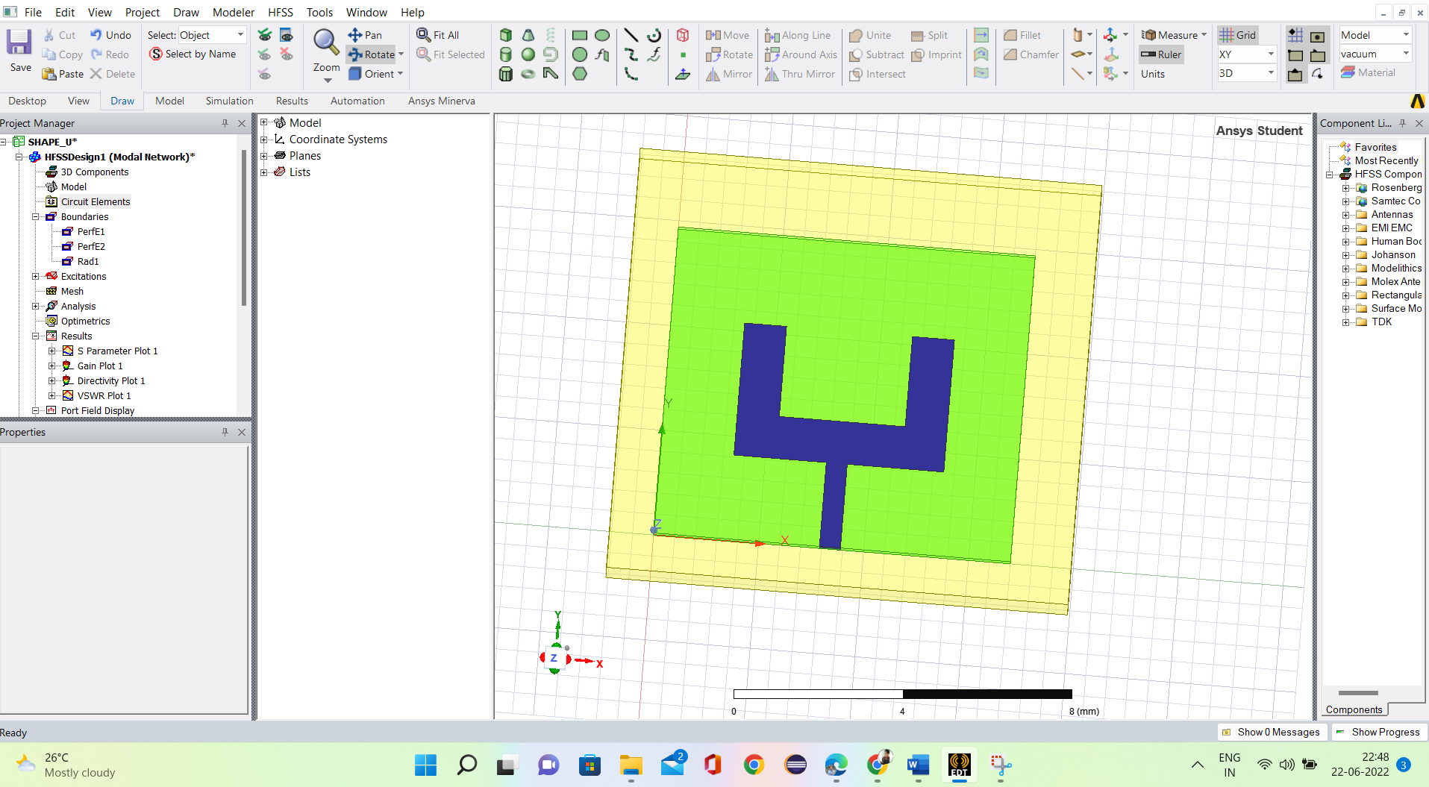

**Figure A**

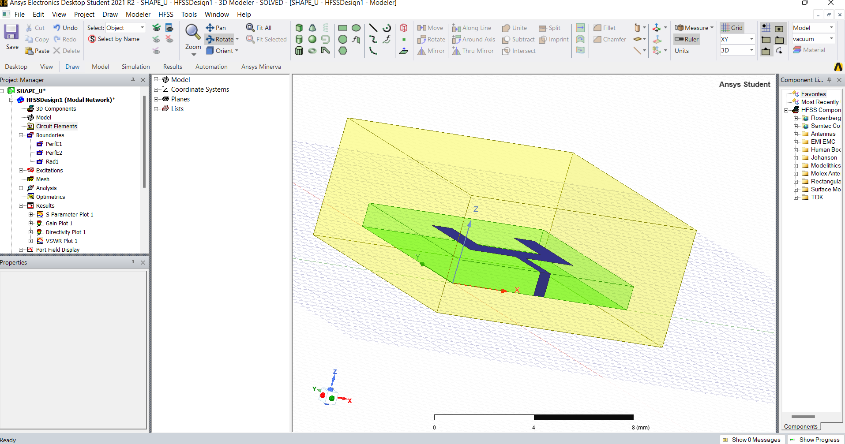

**Figure B**

In HFSS, I placed the planes in the suitable positions of the axis and simulated with analysis option and setting frequency and I created boundaries of perfect E model and created a mesh to radiation box .

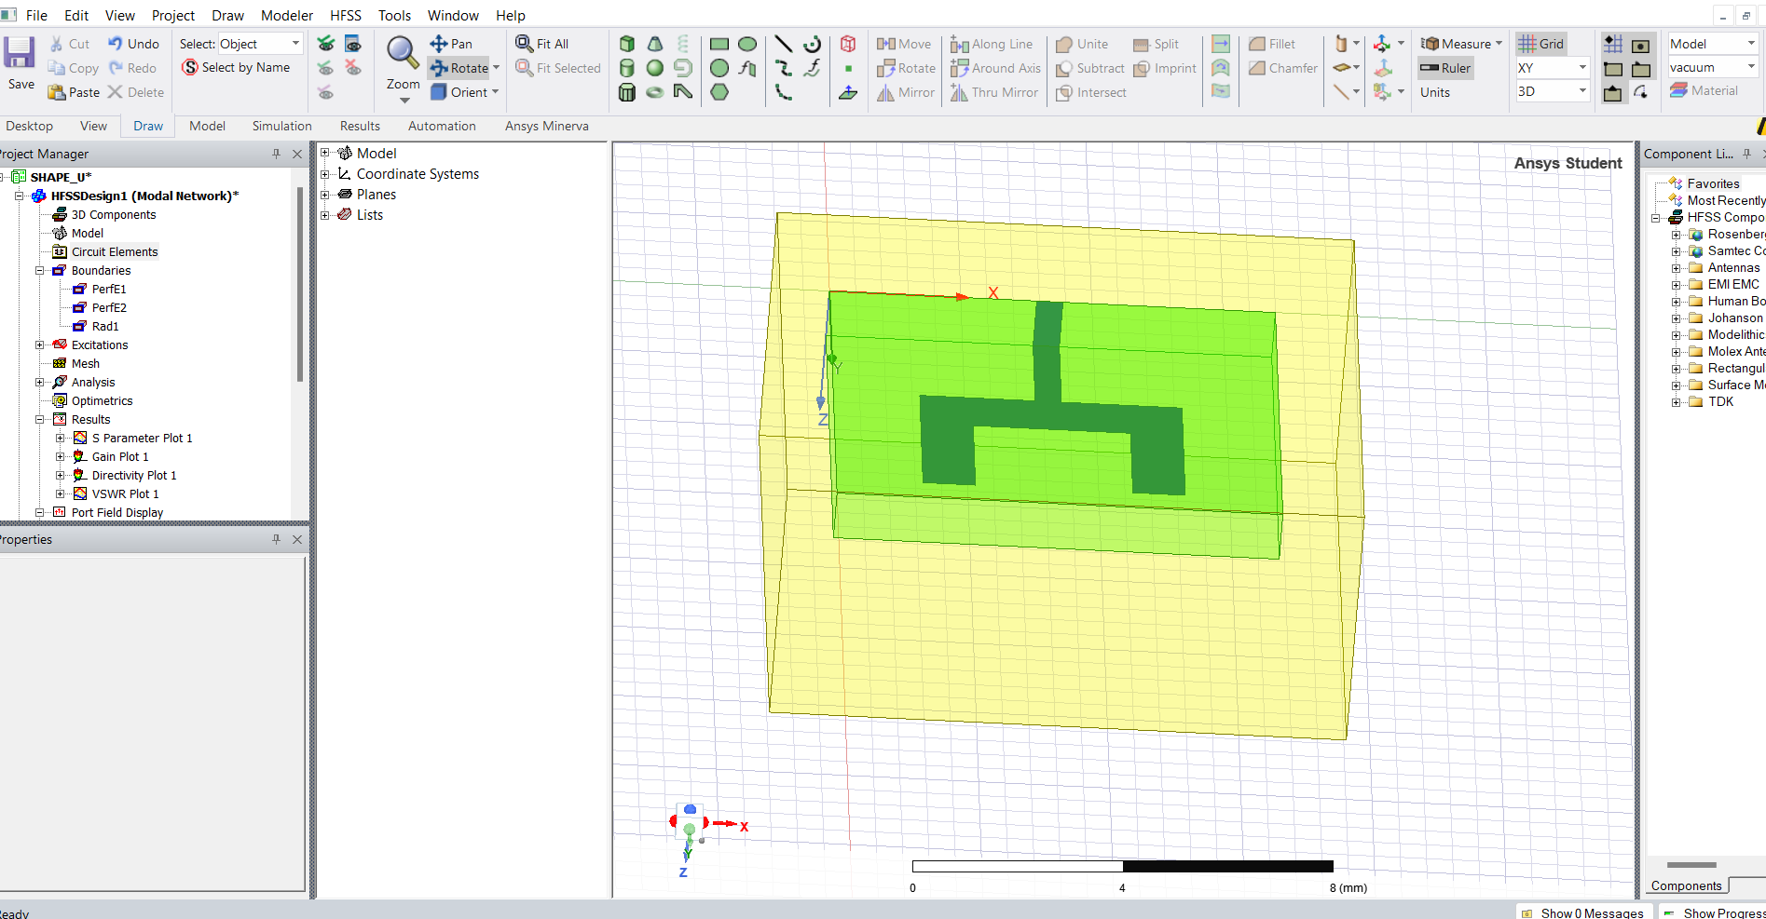

**Figure C**

**SOFTWARES USED:**

HFSS(High Frequency Structure Simulator) from ANSYS free Student version.

**RESULTS:**

The very first parameter is **return loss** is observed(i.e. S-Parameter):

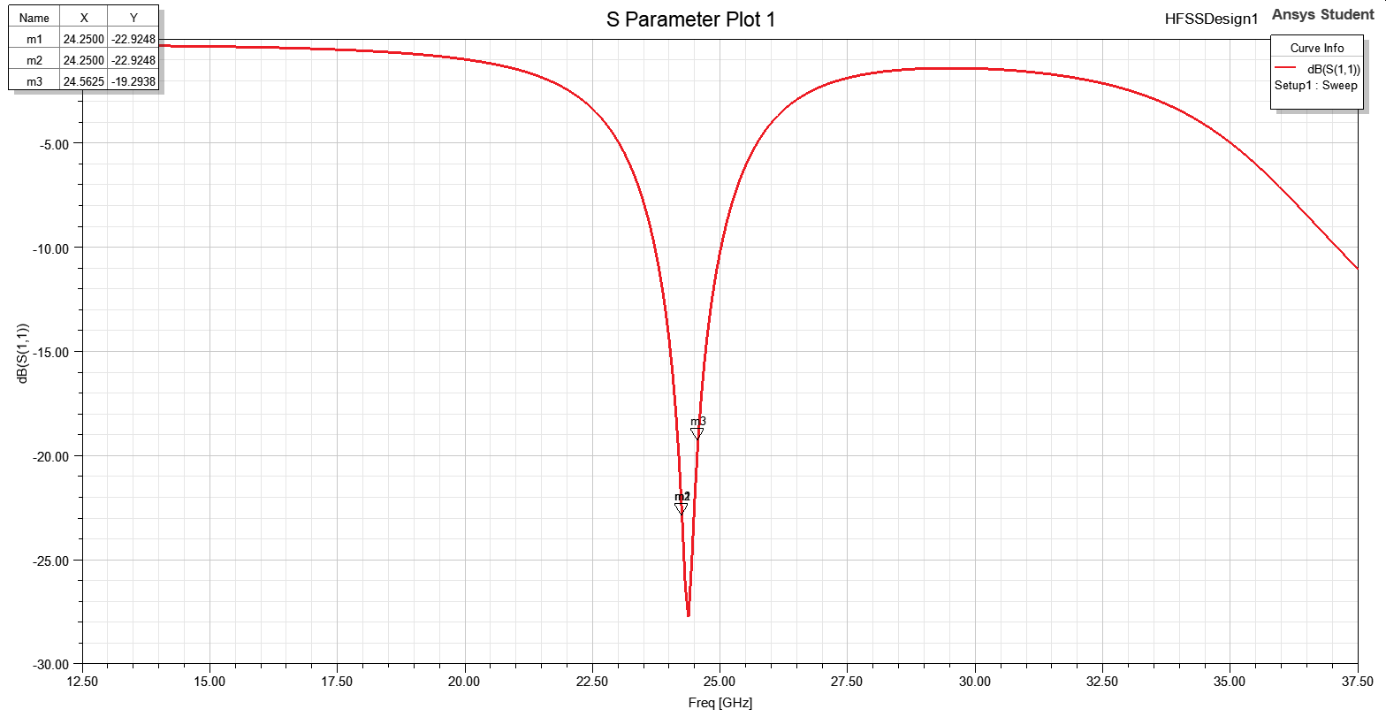

The second parameter is **Voltage Standing Wave Ratio(VSWR)**:

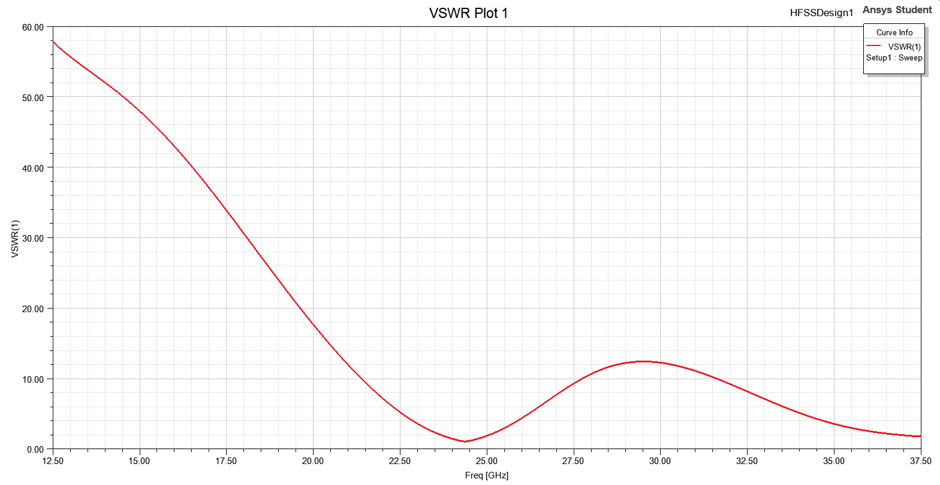

The third parameter is **Total Gain in dB**:

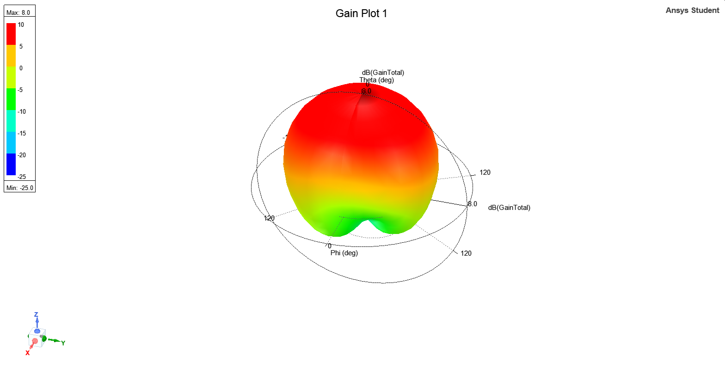

The fourth parameter is **Directivity**:

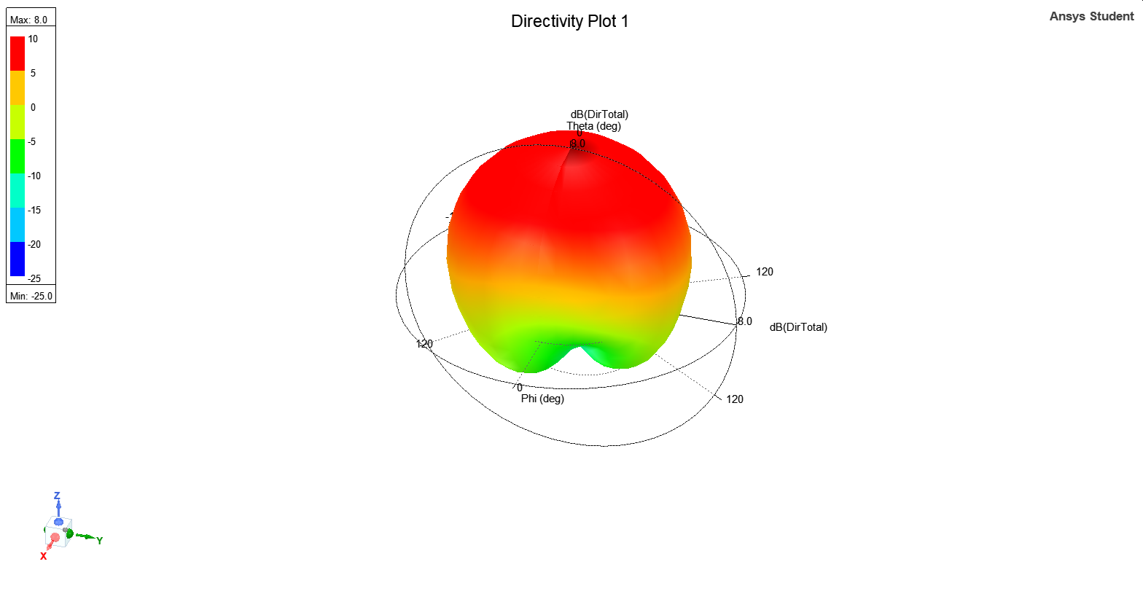

The fifth parameter is **Axial Ratio**:

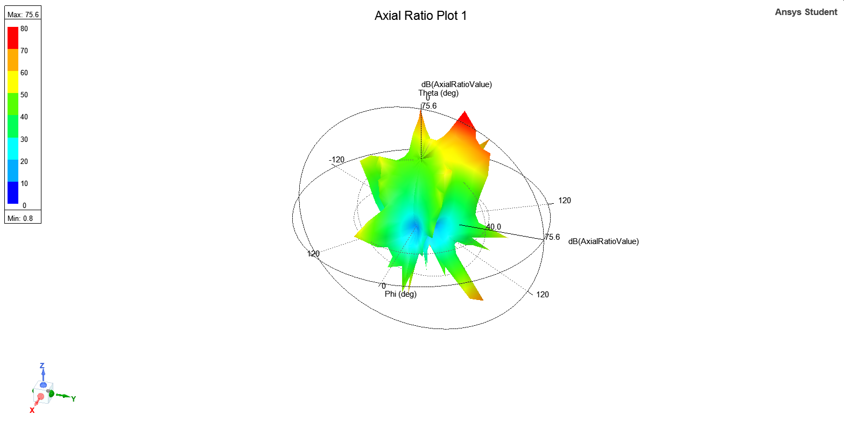

**CONCLUSIONS :**

In this paper, a new dual band microstrip antenna with U-shaped slot is studied. To provide a wideband matching in feeding system, a broadband electromagnetic coupling probe is used. Radiation characteristics of the antenna are investigated experimentally and by numerical simulations. It is shown that the antenna radiation pattern is broadside and cross-polarization level is low at both resonant frequencies. Frequency control method of the proposed antenna is discussed. It is shown that the frequency ratio (*f*2*/f*1) can be easily adjusted by appropriate selection of the structural parameters.

# REFERENCES:

1. Garg, R., P. Bhartia, I. Bahl, and A. Ittipiboon, *Microstrip Antenna Design Handbook*, Artech House, Norwood, 2001.
2. Wong, K. L., *Compact and Broadband Microstrip Antennas*, John Wiley & Sons, New York, 2002.
3. Lu, J. H., “Single-feed dual-frequency rectangular microstrip antenna with pair of step-slots,” *Electronics Letters*, Vol. 35, 354– 355, 1999.
4. Bhalla, R. and L. Shafai, “Broadband patch antenna with a circular arc shaped slot,” *IEEE AP-S Int. Symposium*, Vol. 1, 394–397, 2002.
5. Bhalla, R. and L. Shafai, “Resonance behavior of single U-slot microstrip patch antenna,” *Microwave and Optical Technology Letters*, Vol. 32, 333–335, 2002.
6. Tada, S., R. Chayono, Y. Shinohe, Y. Kimura, and M. Haneishi, “Radiation properties of modified fractal microstrip antennas,” *IEICE Transactions on Communications*, Vol. 89, 1519–1531, 2006.